**Project Design Phase-II**

**Technology Stack**

|  |  |
| --- | --- |
| Date | 25 JUNE 2025 |
| Team ID | LTVIP2025TMID35419 |
| Project Name | transfer learning-based classification of poultry diseases for enhanced health management |
| Maximum Marks | 4 Marks |

**Technical Architecture:**

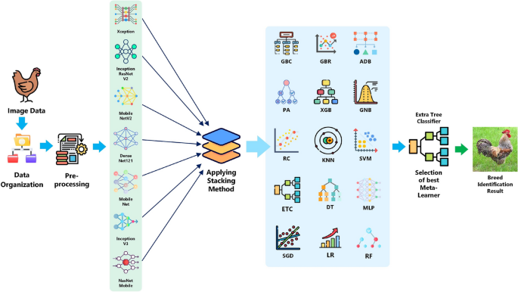

Guidelines:

Here is a filled-in **Technology Component Table** customized for your project:  
**Transfer Learning-Based Classification of Poultry Diseases for Enhanced Health Management**

**Table-1 : Components & Technologies:**

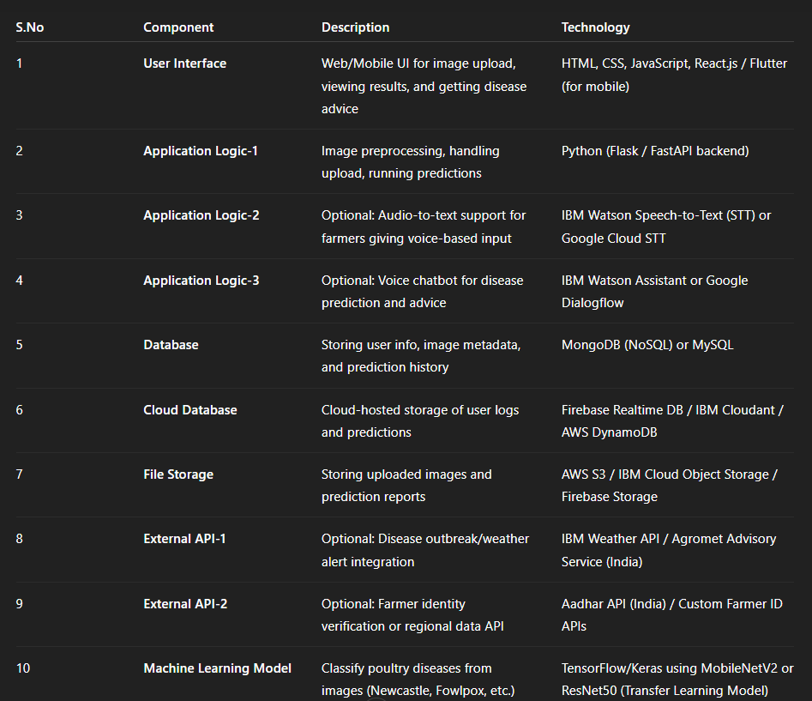

**Table-2: Application**

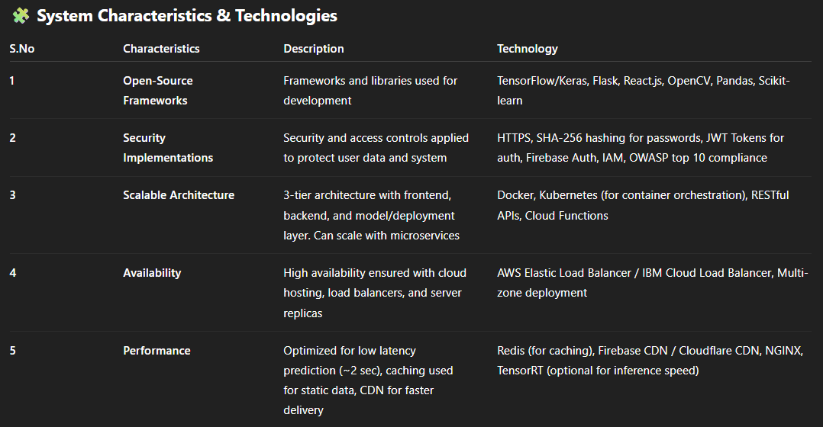

* **ensorFlow Docs:** [**https://www.tensorflow.org/**](https://www.tensorflow.org/)
* **Firebase Docs: https://firebase.google.com/docs**
* **IBM Cloud Docs: https://cloud.ibm.com/docs**
* **OWASP Top 10: https://owasp.org/www-project-top-ten/**